**Manual**

**How to generate Softex forms?**

Follow below link

<https://www.rbi.org.in/scripts/EDF_UserDetails.aspx>

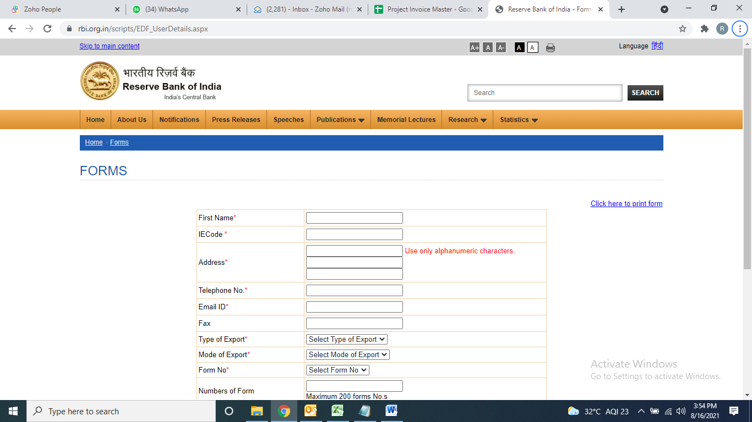

Need to fill all the star marked fields with numbers of forms we need to generate. A pdf file will get generated with the form numbers. Only the form numbers are of use, in that pdf file.

**How to make client contract with STPI?**

Follow below link:

<http://stpionline.stpi.in/unit/jindex.php>

Login using below details:

User ID: stpi2910029

PW: Mit@2018

Select **Export Certification** under the **Export** headfrom LHS menu bar.

Select **Contract details (2nd option)** from the current window.

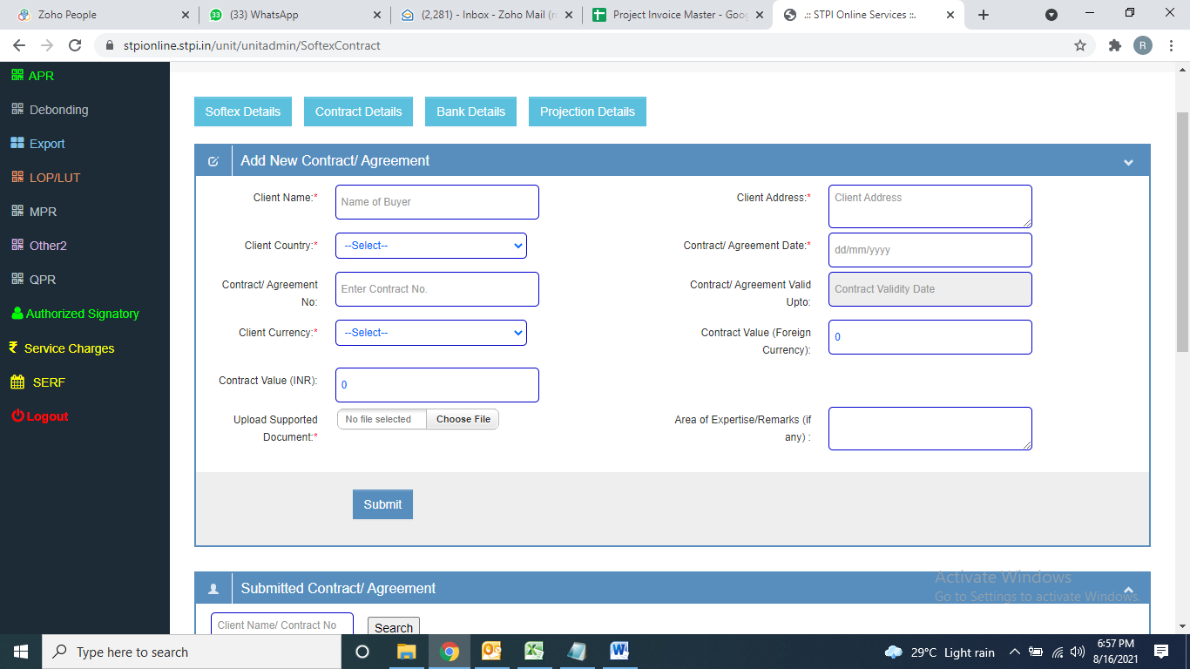

Need to fill all the star marked fields and also upload the signed copy of agreement with that particular client and the **Submit** the same.

A number will get generated after submitting the same, which needs to be saved for future reference.

**How to file MPR month on month basis:**

Follow below link:

<http://stpionline.stpi.in/unit/jindex.php>

Login using below details:

User ID: stpi2910029

PW: Mit@2018

There is a set format from STPI for MPR filing which needs to be filled every month uploaded on the portal

Select **MPR** under the **MPR** headfrom LHS menu bar.

Select month and year for which MPR to be filed and submit (screenshot is below)

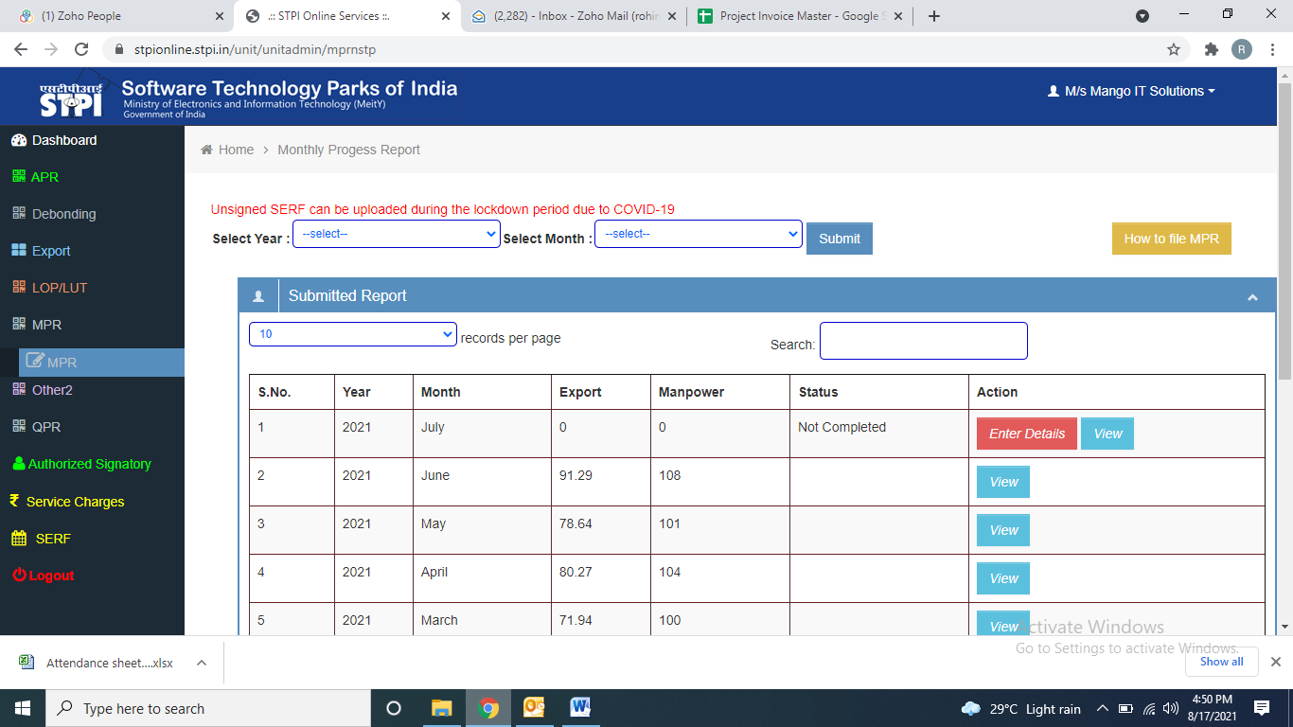

And then press **ENTER Details** as mentioned in above screenshot:

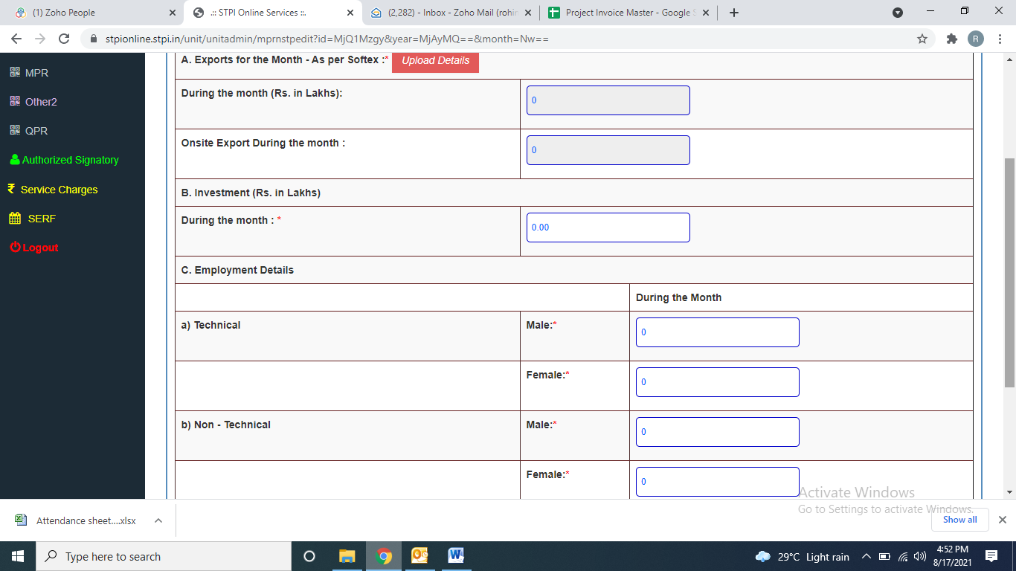

Then press **Upload Details** option

Then on below page upload that sheet (format I mentioned above in which monthly invoice details will be there)

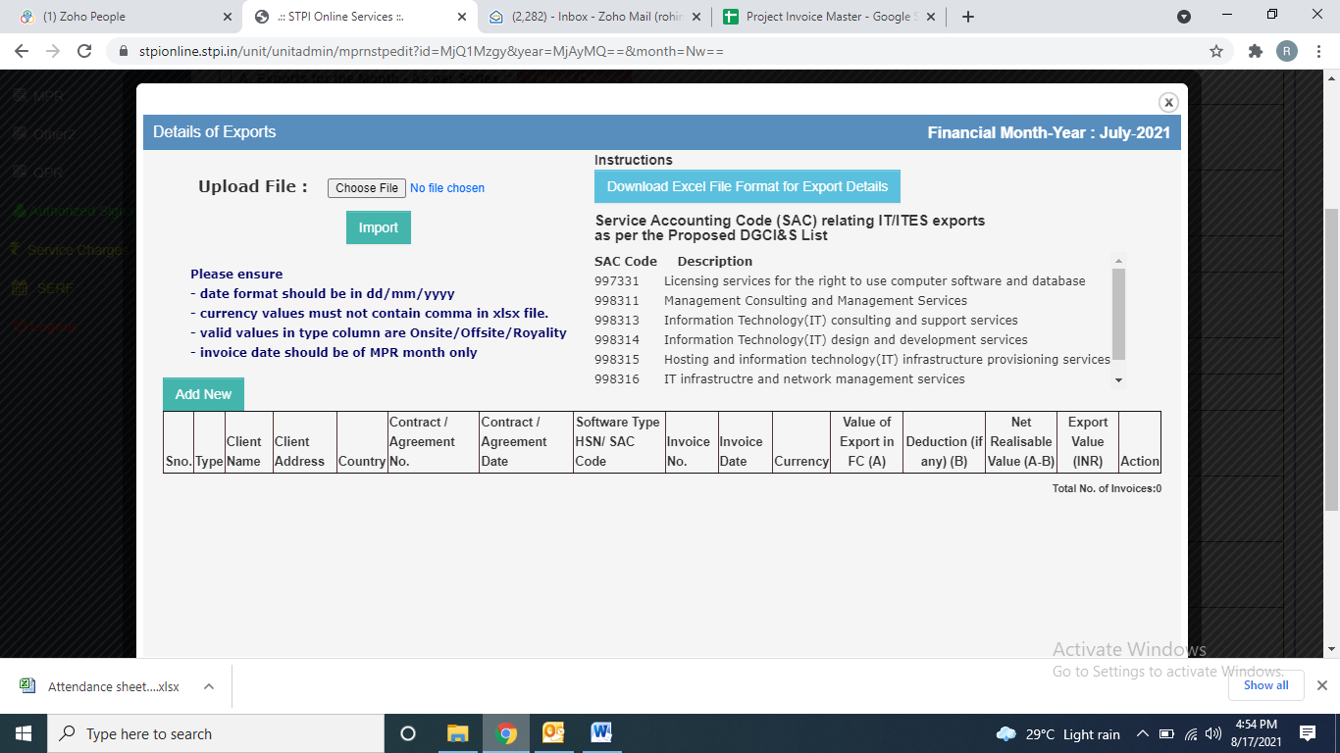

After uploading the sheet **Import** the same, then it will again redirect to previous page:



Now it will automatically fetch the monthly Export(from the uploaded sheet) and then fill rest of the columns:

* Investment details need to be collected from Nishikant ji
* Employment details to be filled from that month’s attendance sheet.

Then select Vivek Sir’s name from drag down option as authorized signatory and finally **SAVE CHANGES.**

Its done, in a day or 2 it will get approved by STPI.

**How to file Softex month on month basis:**

Follow below link:

<http://stpionline.stpi.in/unit/jindex.php>

Login using below details:

User ID: stpi2910029

PW: Mit@2018

There is a set format from STPI for softex filing which needs to be filled every month uploaded on the portal

Select **Export Certification(Softex)** under the **Export** headfrom LHS menu bar.

Select period for which **Softex** to be filed, select AD code of YES bank( as remittances are credited in YES bank), Select Software Export in Softex Type and finally upload the file as per the format provided by STPI and import is (screenshot is below)

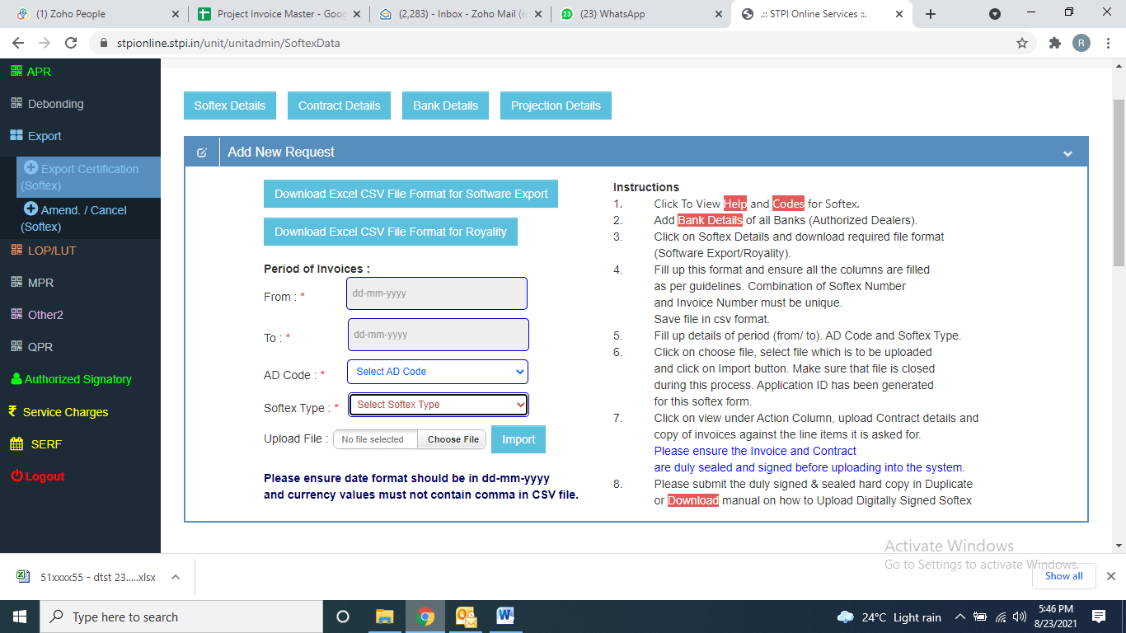

After importing that file below screen will reflect in which that month will start reflecting :

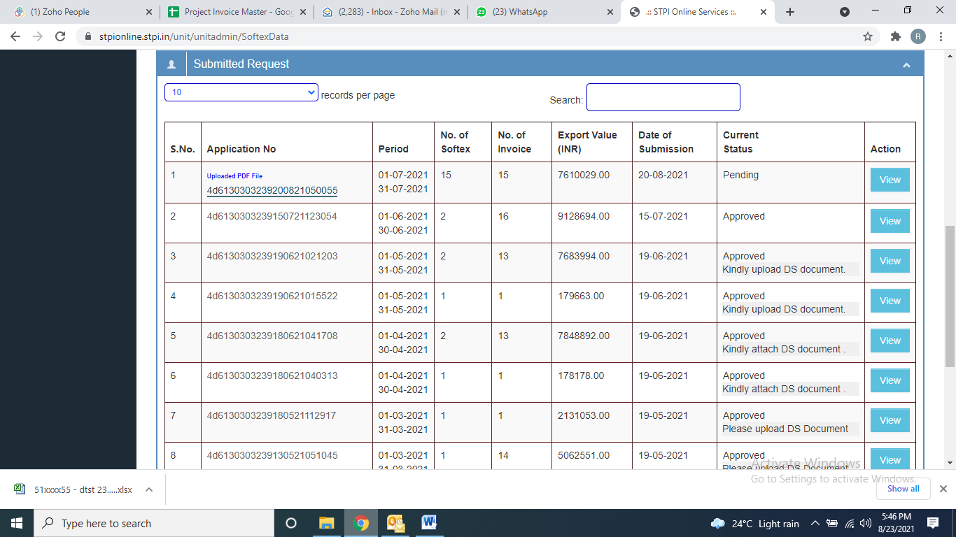

Now it will ask to upload few of the invoices among all the invoices of that particular month.

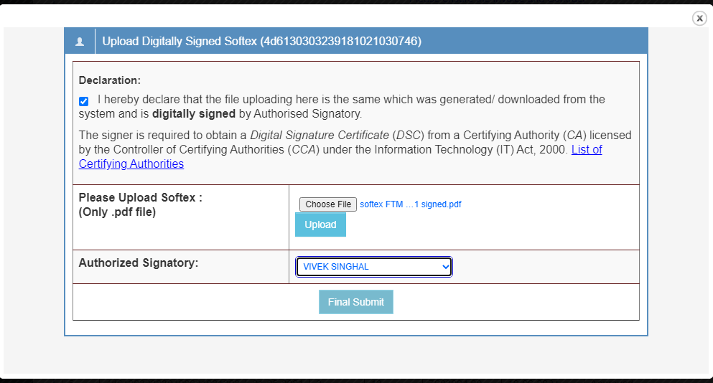

After that we have to send it to company CA for digital signature. After getting the signed copy, it has to be uploaded here. Also we have to attach PDF copy of softex details.

**How to file Softex knock offs month on month basis:**

Its complete manual (PPT) is provided by bank itself. After following the instruction of that manual, lastly need to upload few documents.

We only need to attach below 3 documents in the attachment section:

1. Excel sheet with softex and invoice details.(sheet is already prepared, only monthwise sheets to be added every month)
2. Approved softex by STPI for that particular month.
3. All the invoices of that month (USD and EUR separately) need to be merged 1st and then it can be uploaded.

After uploading above document, we just need to submit the application. After successful submission I save the screenshot as below:

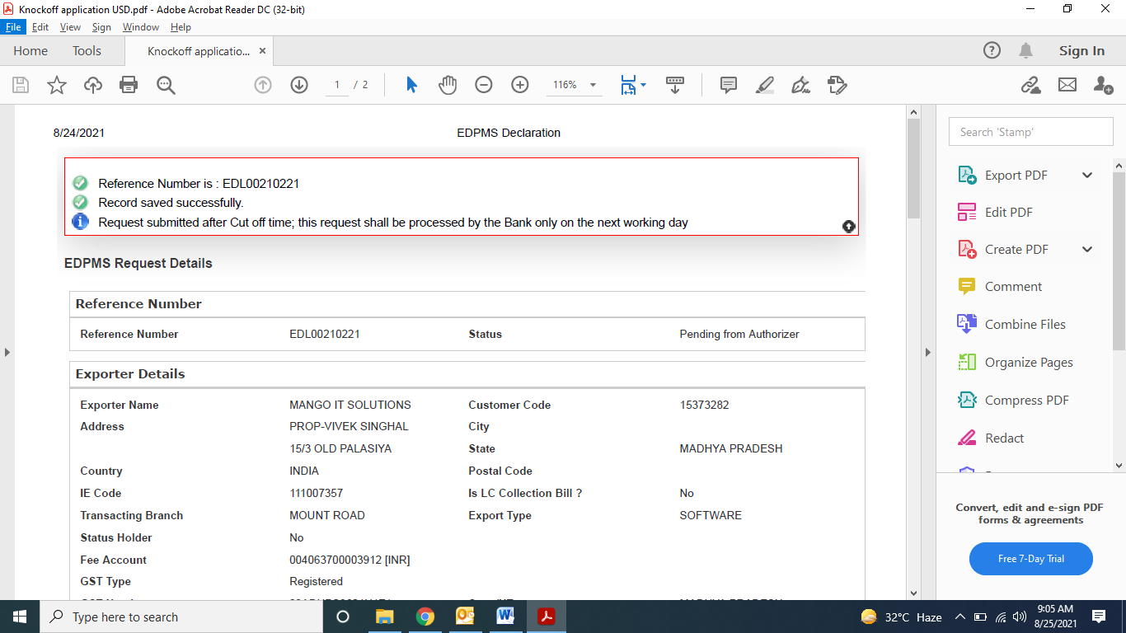

After this Vivek Sir approves the same, and then finally a confirmation email also we receive from bank’s side that our request have been submitted successfully

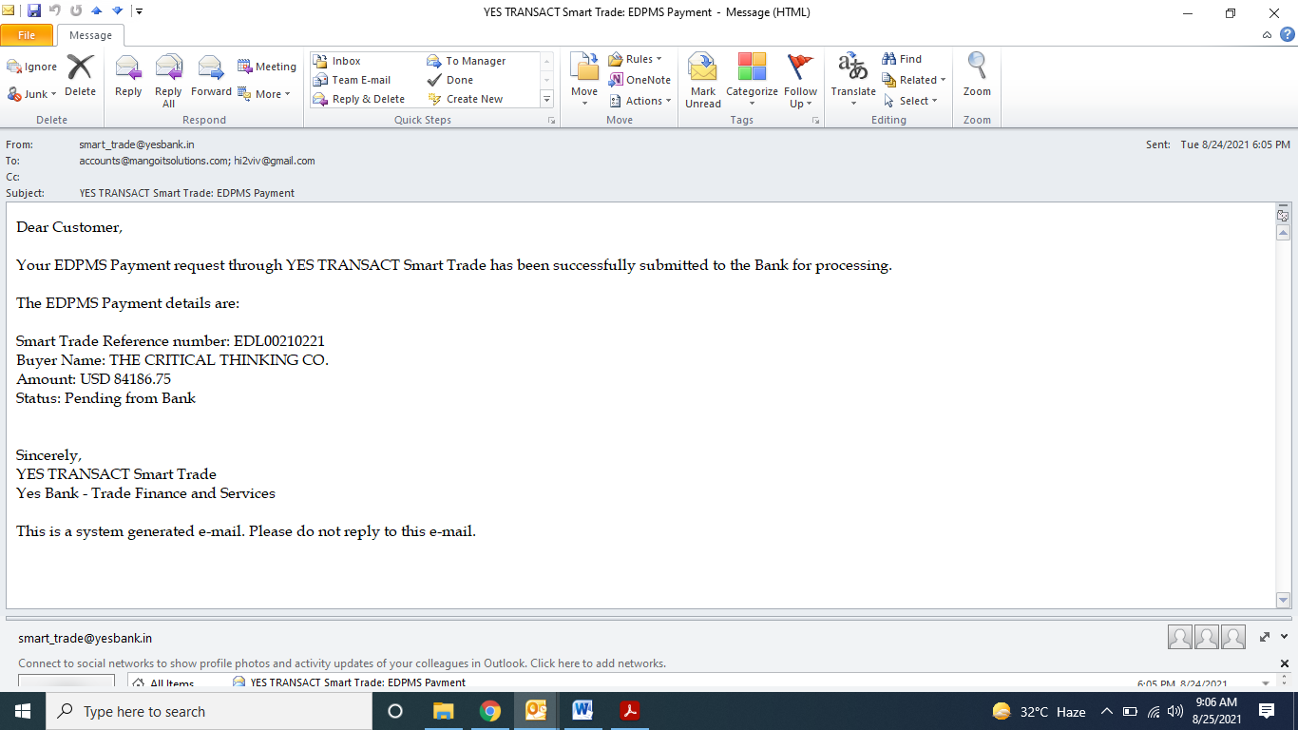

**How to book PCFC ONLINE?**

<https://corporate.yesbank.co.in/corpbanking/entry>

Login ID: ROHINITIWM

PW: Mit@2021

Select **Trade** from **LHS** menu bar

First we will enter the details of applicant details, loan request date, disbursement date, period of loan, all these.

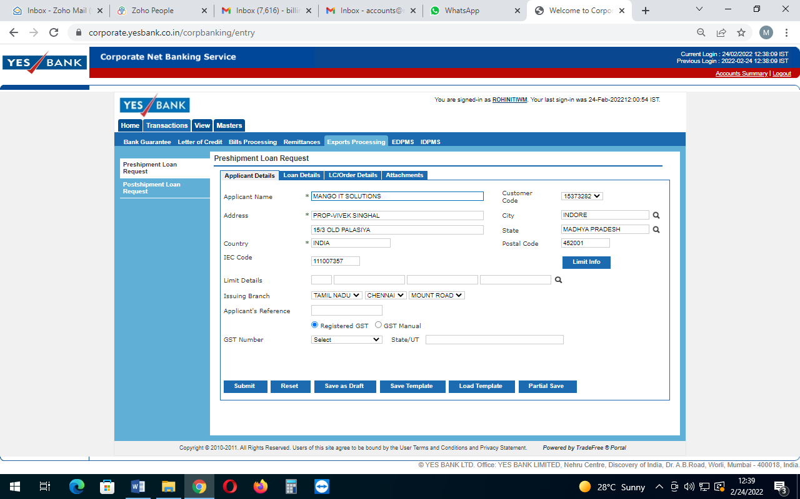

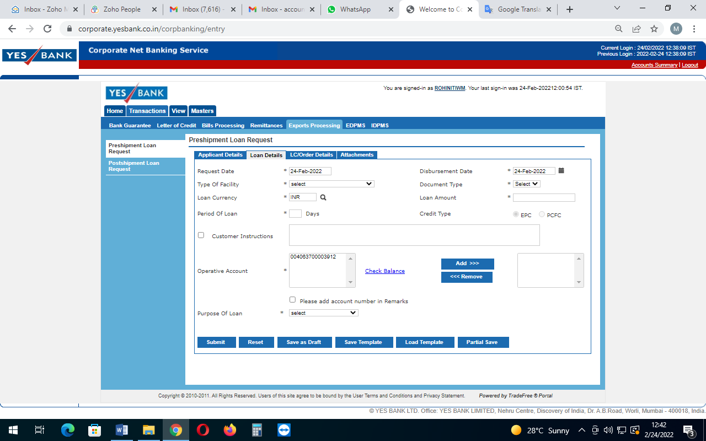

Then select **Transaction,** select **Export Processing,** then select **Preshipment Loan Request**

Rest whole process is there in the manual by bank.

In this we need to attach, Signed copy of invoice (for PCFC of $50K, we prepare invoice for $60K)

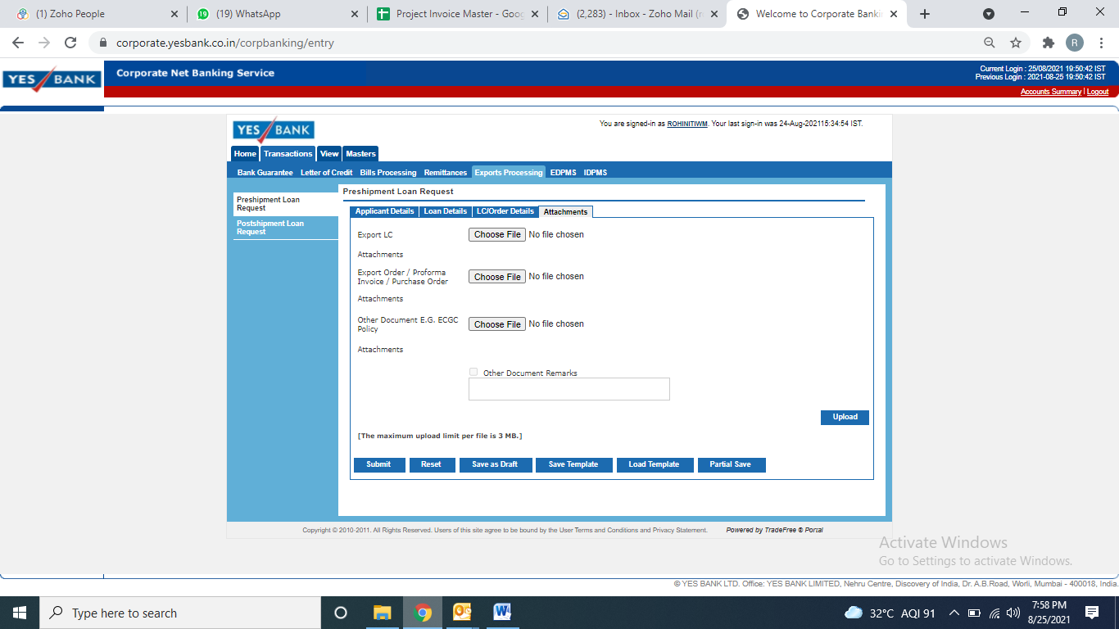

After final submission, need to save the confirmation from bank, later Vivek sir will approve the same.